Laudato Si at 10 Years: Uganda Martyrs – Seeds of Hope for an Integral Ecology
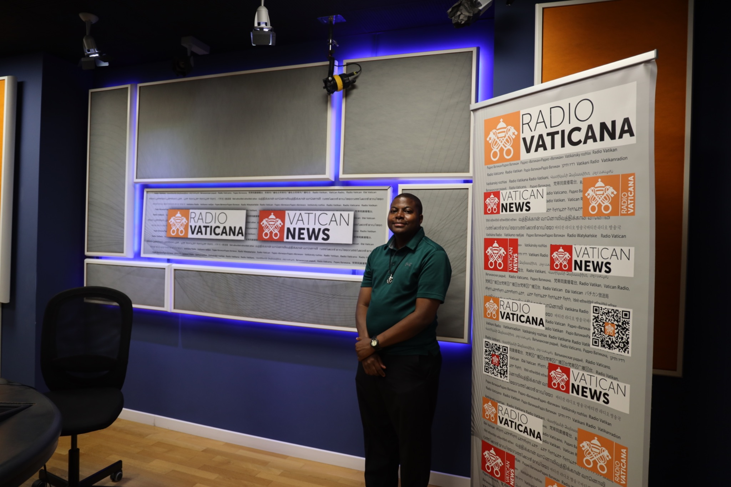
Br. Adolf Mugume, C.S.C., Three Series Interview with Vatican Media about the 10th anniversary of Laudato Si and the Impact of the Laudato Youth Initiative.
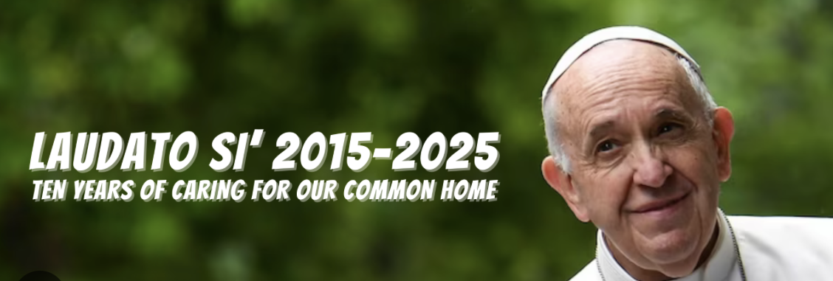
The Year 2025: Jubilee Year of the Church. We shall Celebrate 10 Years since the publication of the encyclical Laudato Si was written.
The Encyclical Letter of Pope Francis, Laudato Si’, released in 2015, marked a global wake-up call for ecological conversion. On its 10th anniversary in 2025, we reflect not only on its message but on those putting it into action. Among these is the Laudato Youth Initiative in Uganda, a grassroots initiative guided by faith, youth engagement, and the heroic witness of the Uganda Martyrs. Vatican Media’s Sr. Jacinta sat down with Br. Adolf Mugume, a religious of the Congregation of Holy Cross and a passionate mentor of the initiative for an interview ahead of the anniversary.
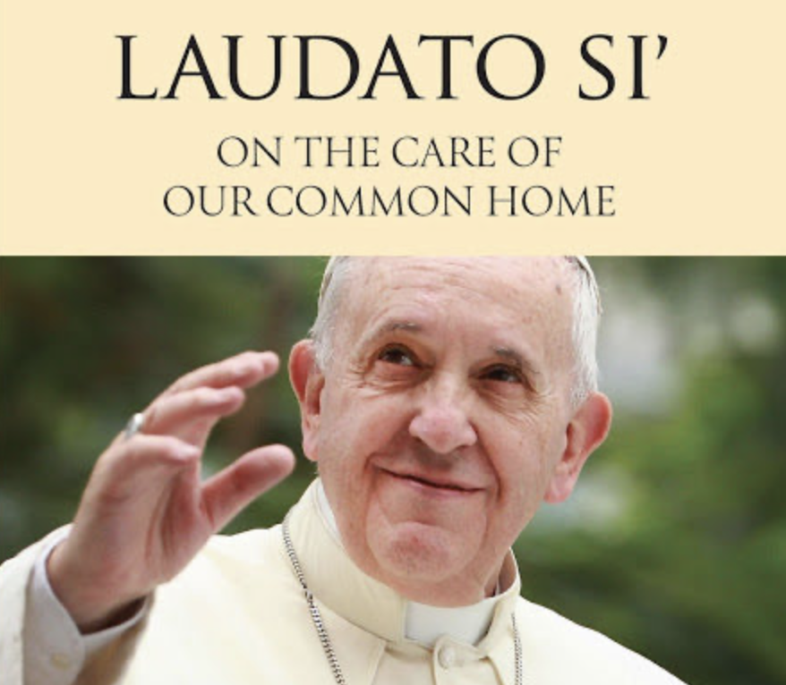
Honoring Pope Francis for his groundbreaking encyclical Laudato Si, and Laudate Deum

Part 1: The Impact of the Laudato Youth Initiative
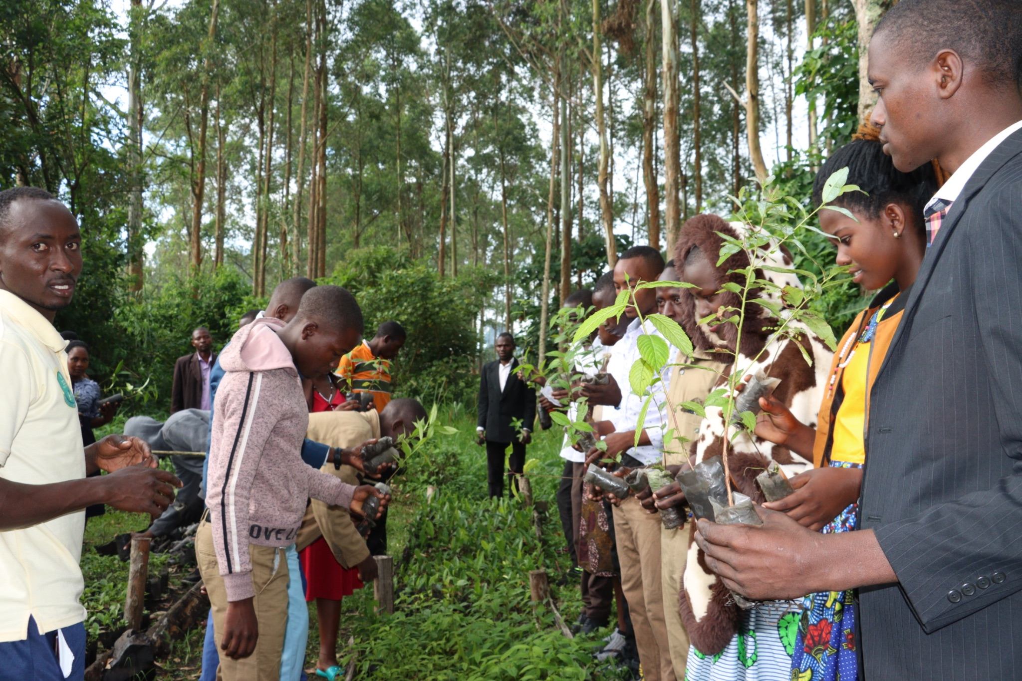
Laudato Youth take on climate action activities during the Laudato Si Week 2024
Sr. Jacinta: Welcome to Vatican Radio! Today, we have the pleasure of speaking with Br. Adolf Mugume, a dedicated religious of the Congregation of Holy Cross, who is here to share his witness and experience as a mentor of the Laudato Youth Initiative. Br. Adolf, thank you for joining us.
Br. Adolf: Thank you for having me! It’s an honor to be here today.
Sr. Jacinta: To begin, could you tell us a bit about yourself and your apostolate?
Br. Adolf: Adolf is my name. A religious of the Congregation of Holy Cross serving here in Rome. I was born in a beautiful little Country Village Saaka village in Fort Portal Diocese, Uganda, and I’ve been involved with the Laudato Youth Initiative since 2020, during the COVID-19 pandemic. My passion centers on youth leaders' mentorship and faith formation, aiming to inspire young people to roll their sleeves and embrace integral ecology rooted in our Holy Father encyclical Laudato Si’, the Catholic Social Teachings, the model of our Uganda Martyrs and the UN’s SDG 13 to reflect and implement our Country environmental laws. Our goal is to foster ecological conversion and empower young people as stewards of the future.
Sr. Jacinta: What inspired you to begin this initiative?
Br. Adolf: During the pandemic, environmental degradation worsened, and youth were locked in, isolated, and overwhelmed. I felt called to respond with the guidance Pope Francis’s message in Laudato Si’ and the Catholic teachings by giving youth a platform to engage meaningfully in climate action via media during the pandemic and now reconnecting with creation and one another after the pandemic.
Sr. Jacinta: Why did you focus on youth?
Br. Adolf: Youth are the future leaders and caretakers of our planet. By engaging them now, we plant seeds of awareness and responsibility. We want to build a generation rooted in faith and ecological justice youth who think differently and act boldly.
Sr. Jacinta: What initiatives have you carried out?
Br. Adolf: Our major activities include a one-million tree campaign, community clean-ups, waste management strategies, the Laudato Si Festival, interfaith climate conferences, and the creation of “Laudato Si Clubs” in schools and communities. We also focus on digital storytelling, Conservation and restoration workshops, and promoting renewable energy. Each initiative embodies our mission of ecological education and sustainable living.
https://youtu.be/8g9UyQC0Eno?si=9qnCVpMadTpoIZja

Part 2: Environment and Mental Health
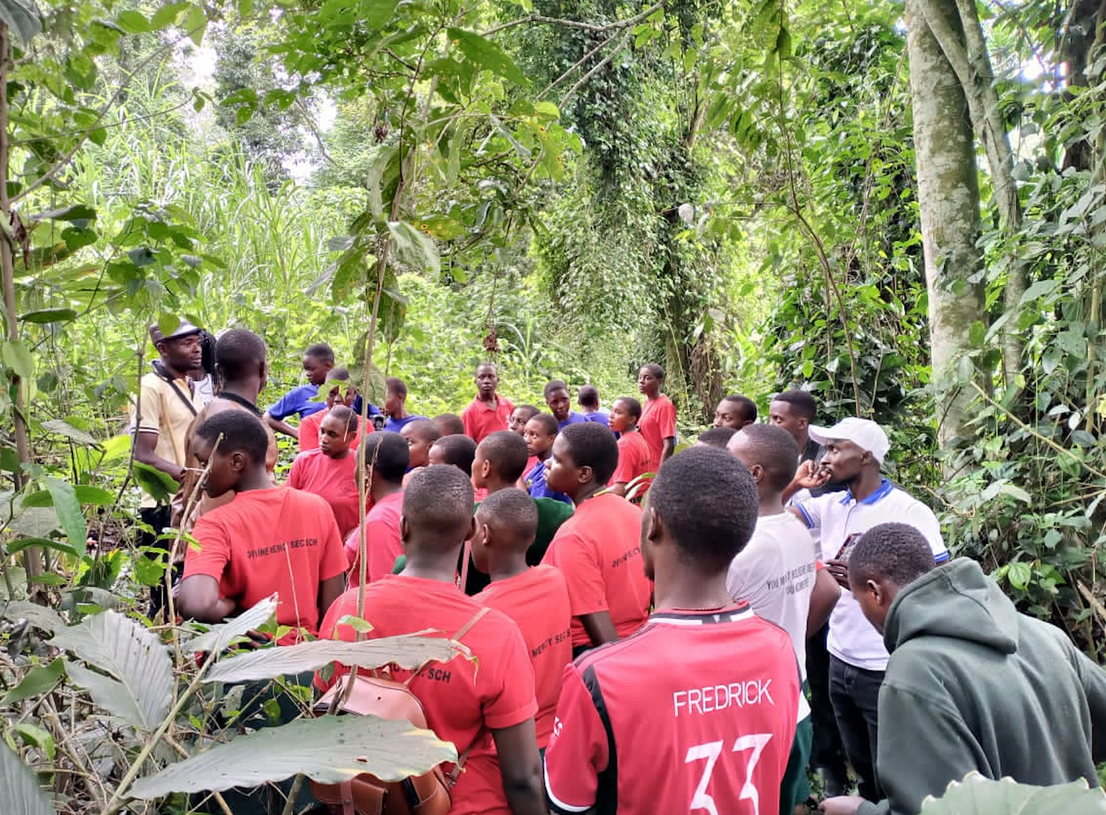
Laudato Youth engage in mental health building activities in Kibaale Forest reserve
Sr. Jacinta: We’ve heard that mental health is also a focus for the Laudato Youth Initiative. How does this connect with environmental care?
Br. Adolf: Mental health is deeply connected to environmental well-being. Climate anxiety is real. Immaculate Kisembo, one of our youth leaders, shared how extreme heatwaves are affecting students’ focus and performance in schools. By caring for the environment, we also care for the inner lives of people. Our approach is holistic—caring for both the earth and the emotional well-being of young people.
Sr. Jacinta: How do you address this in practice?
Br. Adolf: Through awareness sessions, peer support groups in our Laudato Si clubs, and spiritual reflections that emphasize emotional balance and Mental health. We remind young people that while the crisis is serious, they are not powerless. Hope and action go hand in hand.
https://youtu.be/Qcwx6CzGxtw?si=40-TgdvPlXrfmn0nhttps://youtu.be/AMwKqLGjx2Y?si=0CJGP6X2WpvHp_Dh

Part 3: Uganda Martyrs – Seeds of Hope for an Integral Ecology
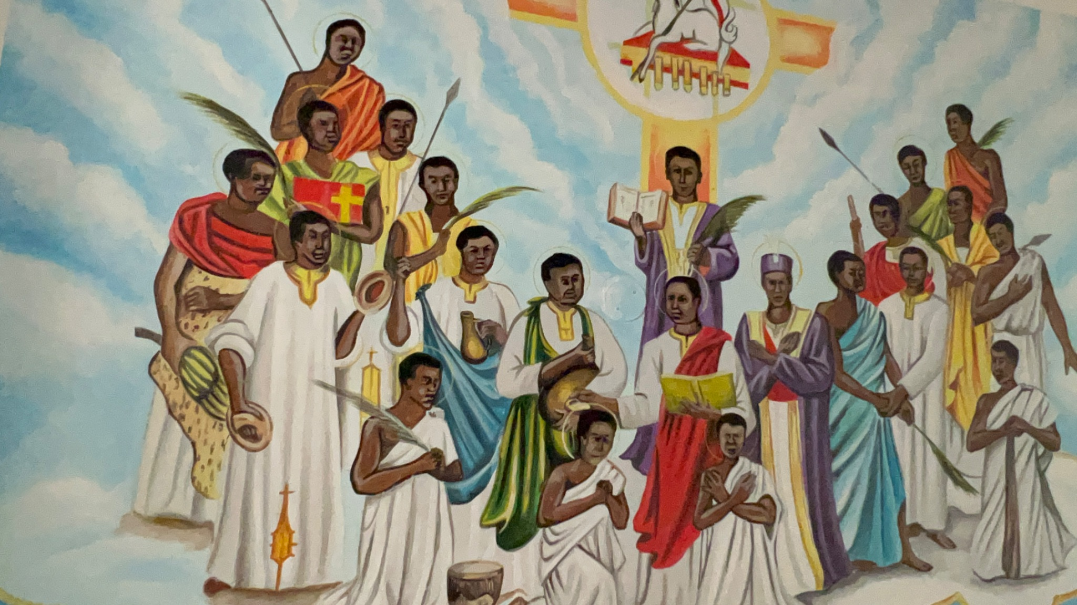
Sr. Jacinta: Your talk about Laudato Youth brings out the story of the Uganda Martyrs. And now that we are here to talk about the 10th anniversary of Laudato Si, how do you connect your story to the Uganda Martyrs? And How do they inspire your work?
Br. Adolf: The Uganda Martyrs were young, faithful, and courageous. We as youth from the Land of the Martyrs see them as —symbols of hope and resilience. We draw parallels between their sacrifice and the courage it takes today to stand for ecological justice. Like them, our youth are called to be witnesses—to stand up against indifference and exploitation of our common home. Their legacy, interwoven with the threads of ecological sustainability, serves as a beacon of hope for us and invites us to be responsible by emulating their example.
Sr. Jacinta: What’s next for the Laudato Youth Initiative?
Br. Adolf: We’re working to expand Laudato Si Clubs and partner with dioceses, schools, and environmental groups. We also hope to amplify the voices of youth and the poor in climate discussions. A key focus is also pushing for more education and Church-level engagement with Laudato Si’.
Sr. Jacinta: What final message do you want to leave as we celebrate Laudato Si at 10 years?
Br. Adolf: This is a Jubilee Year of Hope, a moment of renewal. Let us recommit to ecological conversion and care for our common home. Every action counts. I call upon individuals, parishes, and organizations to walk with us. Let us leave behind a legacy of stewardship for future generations.
Sr. Jacinta: Thank you, Br. Adolf, for sharing your powerful insights and commitment to environmental stewardship rooted in faith. May the seeds of hope you’ve planted continue to grow!
Br. Adolf: Thank you, Sr. Jacinta. It’s been a blessing to share this journey.
https://youtu.be/AMwKqLGjx2Y?si=0CJGP6X2WpvHp_Dh

To learn more or support the Laudato Youth Initiative, follow their ongoing work and witness on social platforms and in your local community. Together, let us nurture the seeds of hope sown by the Uganda Martyrs and grow an integral ecology for generations to come. laudatoyouthinitiative@gmail.com



